1. 
2. Agenda:
   1. Introduction to Transaction in Apache Kafka.
3. 
   1. **All or Nothing**: Either all the Kafka operations within a transaction succeed or none of them.
   2. **Exactly Once**: Each msg is delivered only once.
      1. **Idempotent Producer:**
      2. **Transactions:**
4. 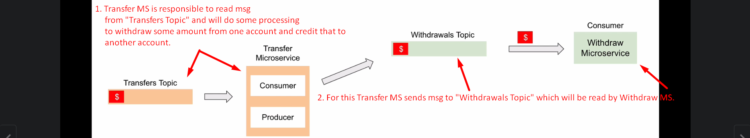
5. 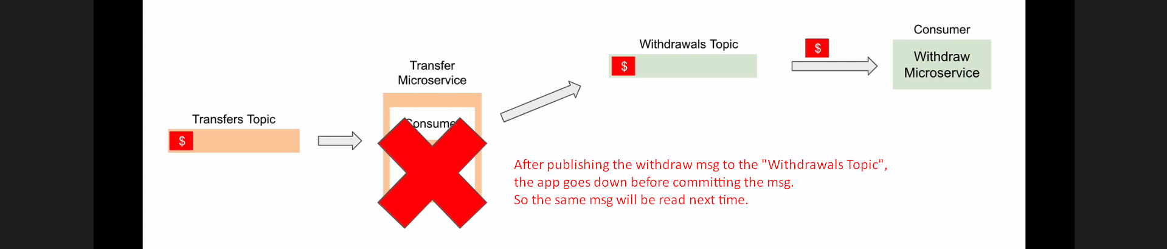
6. 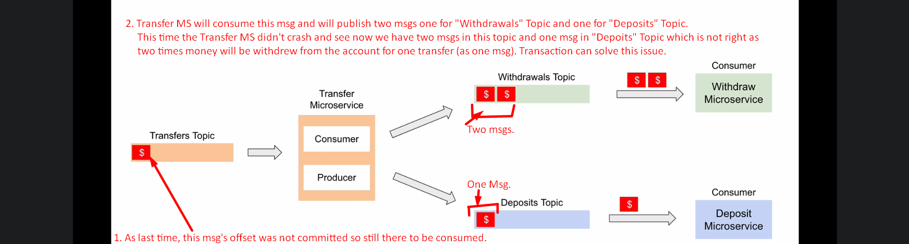
7. 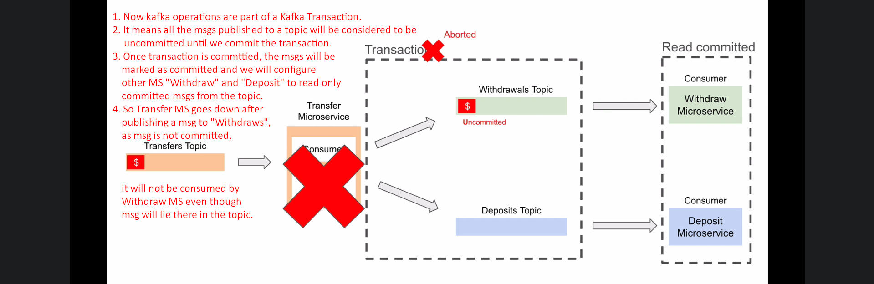
8. See, Transaction helps write to multiple topics atomically thus achieving the “All or Nothing” Behavior.
9. 